**How to download files from GitHub**

1. Create one folder in local Machine and name the folder as a Git Hub Projects
2. Go to the created folder
3. Next right click Then click on open Git Bash here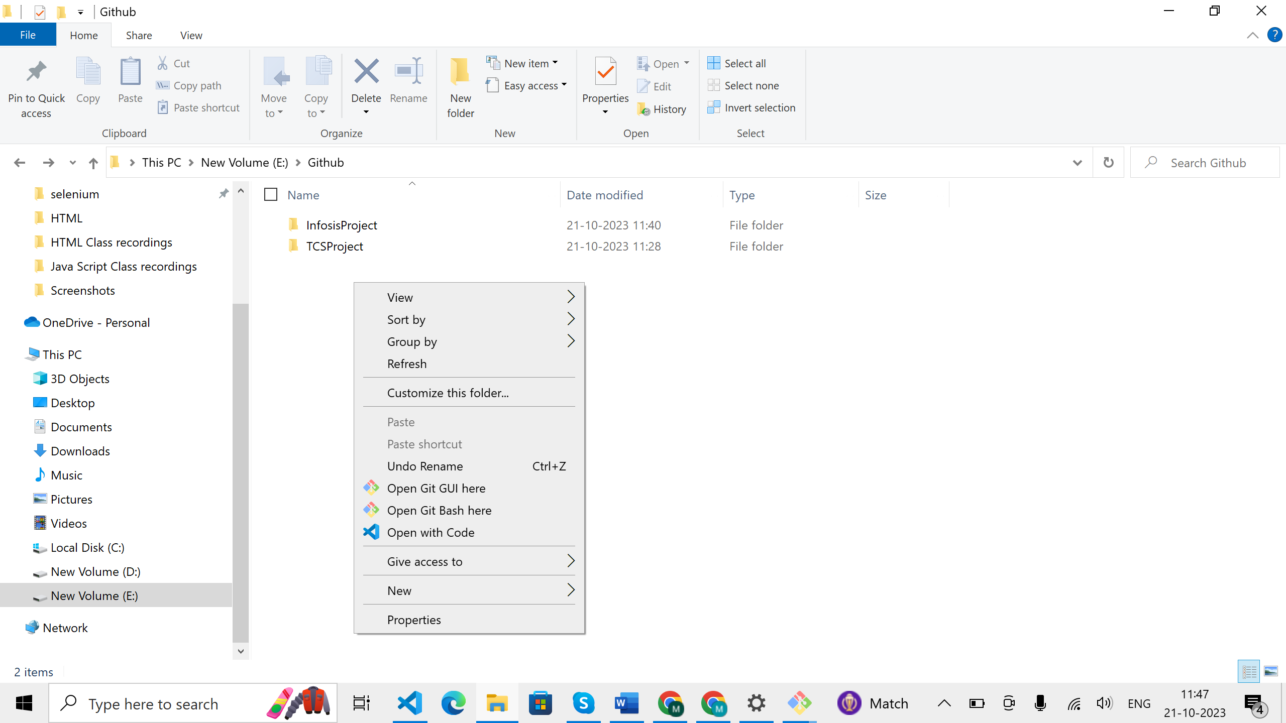
4. Then below will display

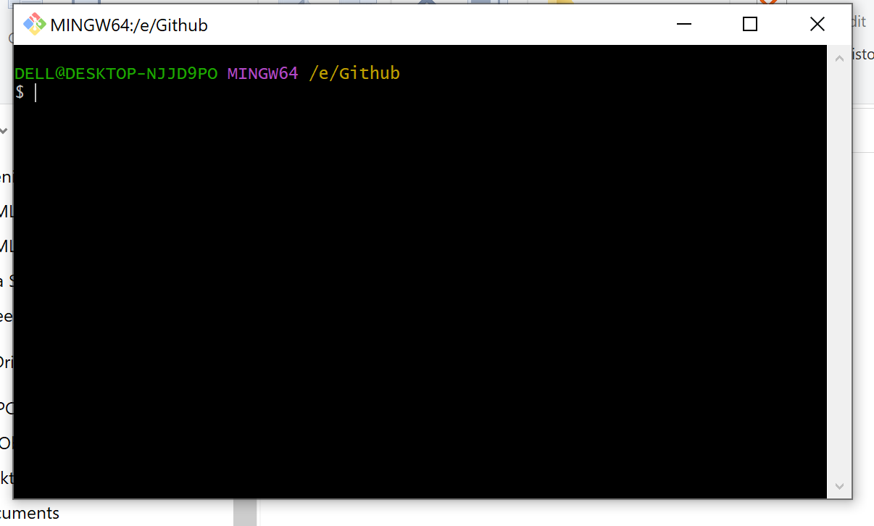

1. Give the Command “git clone” .
2. Copy the project folder from the Git Hub and paste(Right click ) it on GitBash .

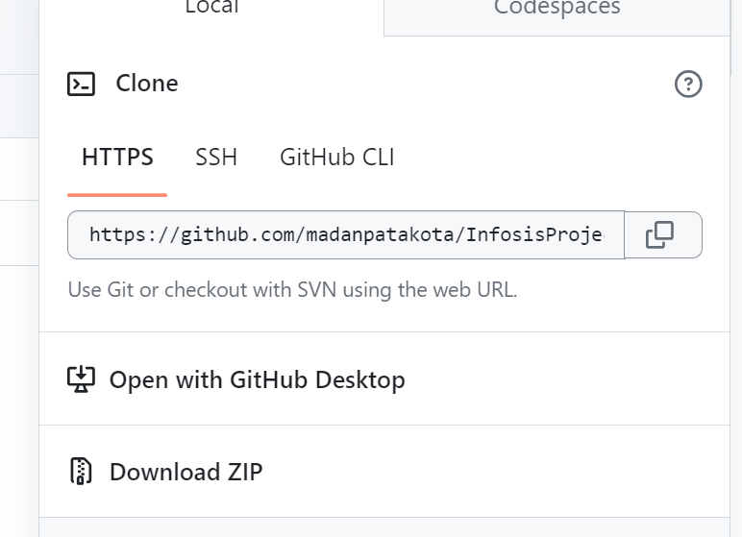

1. Then Project is downloaded in the local Machine 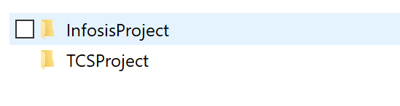

**How To Delete files in GitHub**

1. Go to Chrome and login into your GitHub Account
2. Then Click on settings



1. Scroll down and go to Delete this repository and then click on it.

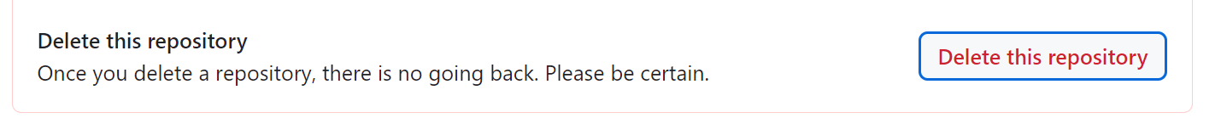

1. Then click on I want to Delete this repository.

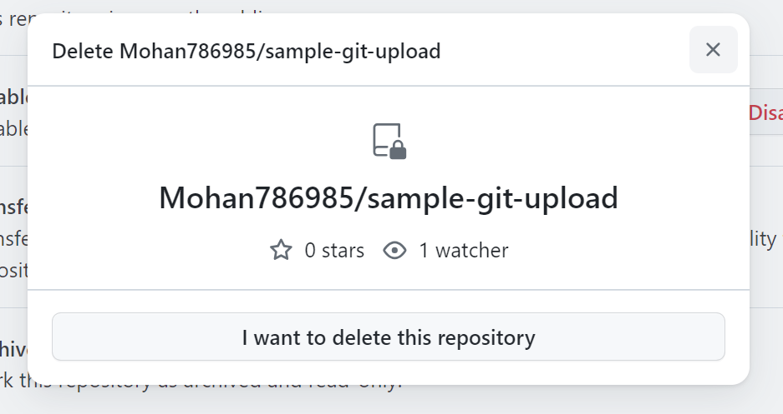

1. Then click on I have read and understand these effects

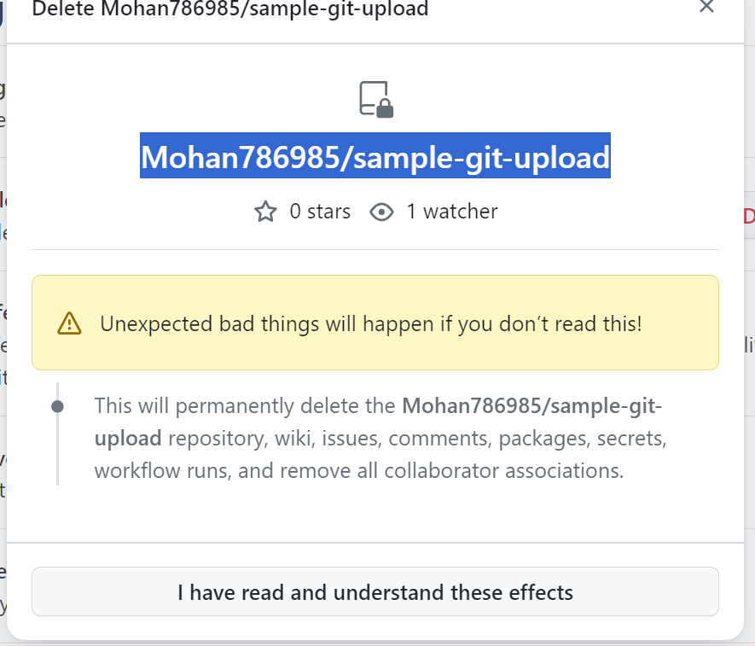

1. Then give file name in the check box and click on Delete this repository . 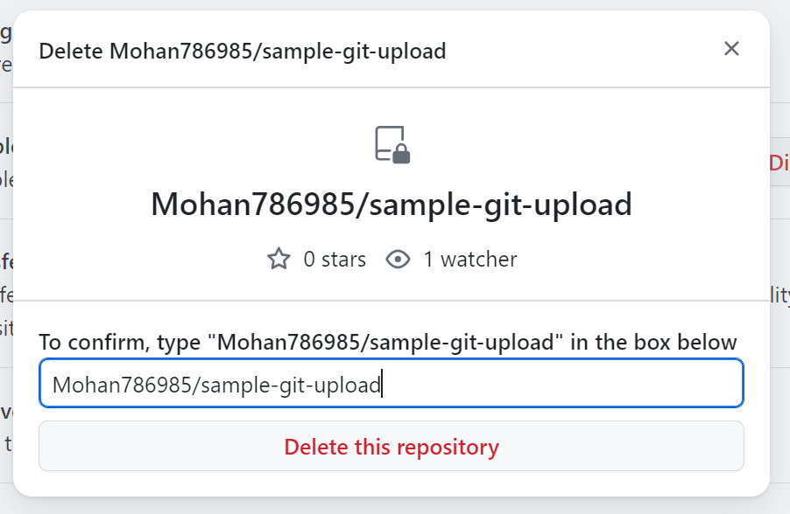
2. Then fill will be deleted permanently in the Git Hub.
3. Then Go to local project folder and right click on it and Delete the required folder.